New Method for Building Vector of Diagnostic Signs to Classify Technical States of Marine Diesel Engine by Torsional Vibrations on Shaft-Line
Do Duc Luu^{1,*}, Cao Duc Hanh ¹, Nguyen Xuan Tru²
¹ Vietnam Maritime University, Hai Phong, Vietnam
² Naval Technical Institute, Hai Phong, Vietnam

* Corresponding author: luudd@vimaru.edu.vn
484-Lach Tray – Hai Phong City – Viet Nam
Abstract. Vector of diagnostic signs (VDS) using torsional vibration (TV) signal on the main propulsion plant (MPP) is the vector of z maxima (or minima) values of the TV signal in accordance with the cylinder firing orders. The technical states of the marine diesel engine (MDE) include R= z+1 classes and are presented in z-dimensional space coordinate of VDS. The presentation of D_{k}, k=1÷R using z diagnostic signs (V_{i}, i=1÷z) is nonfigurative and quite complicated. This paper aims to develop a new method for converting VDS from z-dimensional to 2-dimensional space (two-axes) based on working angle θ of a cylinder. The new vector of diagnostic signs VN is constructed as the geometrical grand total of all VDS:$\vec{VN}={VN}_{x}\vec{i}+{VN}_{y}\vec{j}$, where${VN}_{x}=\sum{V_{ix}}$; ${VN}_{y}=\sum{V_{iy}}$; $V_{ix}=V_{i}.cos{({}_{i})}$ and$V_{iy}=V_{i}.sin{({}_{i})}$. The proposed model is useful for presenting a technical state D_{k} in two-dimensional space (x, y) for better visualization. The paper verifies the simulation of the classification illustration of the 7–state classes for the MDE 6S46-MCC, installed on the motor vessel (MV) 34000DWT, using the new above mentioned method. The seven technical state classes (for 6-cylinder MDE) are drawn separately and visually in the Descartes. The received results are valuable to improve smart diagnostic system for analyzing normal/misfire states of cylinders in operation regimes.
Keywords: two-dimensional vector of diagnostic signs of torsional vibration signal, new model of VDS for misfiring diagnostics of MDE, vision diagnostics of MDE by torsional vibration signal.

Abbreviation list
CF Vector of firing coefficients
DO Diagnostic object
DoE Design of Experiments
DWT Dead weigh tonnage
MDE Marine diesel engine
MPP Main propulsion plant
MV Motor vessel
SATVC Software for automatic torsional vibration calculation
TV Torsional vibration
TVS Torsional vibration signal
VDS Vector of diagnostic signs
VN New vector of two equivalent elements
- Background
The TV signal (TVS) contains much important information about the misfiring / normal working conditions of every cylinder in the multi-cylinder marine diesel engine (MDE) [1]. The characteristics of the TVS identifying in time or frequency domains are used to estimate the technical states of the diagnostic object (DO) and called diagnostic signs.
In the works [1, 2, 4], the VDS are formed from the maxima (VA) or minima (VB) of the TVS correspondence with firing order of each cylinder. The size of the VDS is equal to the number of cylinders in the DO. The z-dimensional VDS are used for classifying the technical states (normal /misfiring conditions) of every DME cylinder, in this case DO is 6 cylinder MDE type 6S46 MCC-7 of MAN-BW manufactory.
It's hardly to illustrate every technical state D_{k}, k=1÷R in z-dimensional space V= [V₁…V_{z}] of the VDS (V=VA or V=VB; VA= [VA₁... VA_{z}] or VB= [VB₁... VB_{z}]) because imagining mathematic models in the multi-dimensional space is quite complicated. In many cases, the illustration of D_{k} (V₁, V₂ … V_{z}) is divided in to a number of a pair of two-dimensional space (V_{i}, V_{j}); i ≠j, i=1÷z; j=1÷z [4].
To overcome the above-mentioned presentation inconvenience, the authors convert VDS from z-dimensional to 2-dimensional space. From there, the diagnosis and identification processes could be solved in a more visualization way and easily applied in real-world diagnostic problems.
- Research Method
  - Modeling new two –dimensional VDS from VA or VB
Let us assume that the TV signals are simulated (or measured) in a working cycle of MDE containing z cylinders. The signal normally has a number of samples, N=1024 or 2048. The signal is divided in to z parts, and every part has N_{c} = [N/z] samples. In the part in accordance with firing order of every cylinder, we find the maximal and minimal values. We conduct the VA and VB vector of the diagnostic signs from these values.
The firing order of every cylinder is given in the MDE technical documents, such as the 6S 46MCC shows the order [6]: 1-5-3-4-2-6. The parameter features (VAm, VBm) of m^{th} –cylinder are de-phased α_{m} (degree) in accordance with the first cylinder (two-stroke diesel engine): α₁=0; α₅= 60º; α₃= 120º; α₄= 180º; α₂= 240º; α₆= 300º or in radian: α₁=0; α₅= π/3; α₃= 2π/3; α₄= π; α₂= 4π/3; α₆= 5π/3.
In generally, we conduct the de-phase vector of the working cylinders α:
α = [0, α₂…α_{z}], (radian) (1)
The new diagnostic vectors VN are calculated as follow:
(2)
Where, V= [V (1), V (2) … V (z)], and V=VA or V=VB.
Every class D_{k} is written by two reference parameters: the mean vector μ_{k} and the covariance matrix K_{k} in accordance with the two-dimensional VDS VN= (VN_{x}, VN_{y}), k=1÷R.
Illustration of the cylinder working conditions in the Descartes (VN_{x},VN_{y})
The z –cylinder MDE is classified into R =(z+1) technical classes D_{k} as above mentioned for diagnostics of the normal or misfiring state of cylinder in accordance with the Rules for Classification and Construction of Sea-going Ships [7].
The block scheme for building the new VDS VN (VN_{x}, VN_{y}) and illustrating the R states via the 2-dimensional space is shown in Fig.1.
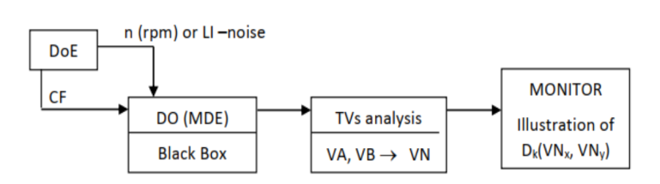
Fig. 1 Block scheme for building new VDS in two-dimensional space VN(x, y)
DoE –Design of Experiments, CF –Vector of the z firing coefficients, MDE as a DO; VA, VB –vector of diagnostic signs (z elements of maxima or minima);VN –new vector of two equivalent elements in two-dimensional space (x,y)

In measuring process, we supposed that the revolution n (rpm) and the Load Index (LI) are fixed. However, the real measured signal has some random components and measuring errors. Therefore, we conducted the measuring process ten repeated times with random noises, and the measurement device error is ±5%. This ±5% is bigger than almost thresholds of precise measuring devices in the market today [4].
The main controlling parameters of the technical states of all cylinders are firing coefficients, which are written in the form of vector CF = [Cf (1)… Cf (z)]. The real firing processes are random and for diagnostics model, we assume that firing coefficient Cf (k) is varied with ±5% in accordance with the mean value. In the case of normal working, the Cf = [0.9, 1.0], and with the misfiring state, Cf = [0.0, 0.1]. For every cylinder there are three levels of one firing regime to be examined.
The design of experiments has N_{n} revolution regimes, for example n_{mean} = 75 rpm, the ΔN=5%.75 =3.75. We would carry out the numerical experiments at N_{d} = {71÷ 79} (rpm), for example at the n_{mean} = 75 rpm, N_{d} = 9 experiments.
The design of experiments has R= (z+1) technical state classes. Thus, we conduct N_{s} = 3^{z} experiments for every revolution regime. For example, z=6, N_{s} = 729.
The total number of experiments of the DoE is N=Nd*Ns. Let us assume z =6, and we conduct each revolution 10 times (in accordance with the real measuring repeat times, N_{d} =10), the total N is 10* 729 =7290 (experiments).
After building database from the measured (simulated) TVS, the authors analysis TVS to find the VA or VB, and finally constructing the new VN-database for the R= (z+1) = 7 states. The VN–database is drawn visually in the two-dimensional (VN_{x}, VN_{y}) axes, in accordance with Eq. (2).
To diagnose the misfire of any cylinder in the multi-cylinder MDE by classification methodology we have to make the new standard diagnostic characteristics and new diagnostic classifier using the new vector of diagnostic signs VN(x, y).
  - Modeling standard characteristics of MDE on the new VDS VN(x,y)
The technical states of MDE are grouped in to R=z+1 classes, written with the symbol D_{k}, k=1…R. Every class has the called referenced (standard) characteristic to identify one with other [1]:
(3)
The covariance matrix K_{k} is calculated
(4)
  - Diagnostics classification of MDE on the new VDS VN(x,y)
The current considered state D_{c} is presented in the similar form with Eq. (3) in the following [1, 4]:
(5)
The solution of the diagnosis is finding minimum of Mahalanobis distance d_{ck} from distance set:
(6)

The Mahalanobis distance between two classes “c” and “k” is defined below
(7)
Where, K_{ck} – compound covariance matrix of the two matrixes K_{c} and K_{k}

- Cases study: Building the two-dimensional VDS for diagnosing the 6S46 MCC
The MDE type 6S46 MCC is installed on the general cargo motor vessel with 34000 DWT (MV 34000 DWT). The TVS of the ship MPP are conducted and supposed to DNV (register) approve by HuDong manufactory [6]. The method and software for automatic torsional vibration calculation (SATVC) are developed at Vietnam Maritime University [0, 5] for this MPP on LabView platform. The SATVC has the features to automatically calculate one of the 7 normal/ misfiring states of the 6 cylinders with revolution regimes N= [0.4, 1.2] NMCR, where N_{MCR} -maximal continuous rate (rpm) and in this case of MV 34000 DWT, N_{MCR} =129 rpm.
For diagnosing technical states normal / misfiring, the diagnostic revolution regimes have to be far from resonance revolution ranges of the torsional vibrations of the MPP because in the resonance or near–resonance revolutions the TVS are quite excited and too large. Therefore we have to calculate the freedom TV for the MPP.
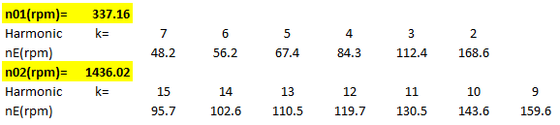
Table 1 Freedom resonances of the MPP on the MV 34000 DWT
The resonances of the first and second modes of the MPP on the MV 34000 DWT are also defined by the SATVC, especially by the freedom torsional vibration module. The results of the freedom TVs are shown below [3, 4]: n₀₁=337.16 rpm; n₀₂= 1436.02 rpm. The revolutions of the DME on the MV 34000 DWT at the interval [52, 155] rpm are resonances that are shown in Table 1.
The interval N_{d} = [71, 80] is selected for diagnostic revolution regimes.
The two-dimensional illustrations of the seven technical normal or misfiring conditions in cylinders of the DO are shown in Fig.2 using the simulation software which is developed in LabView by authors.
Fig. 2 illustrating the seven classes of the MDE 6S46MCC on MV 34000 DWT via new two-dimensional space (VN_{x}, VN_{y}) in accordance with VDS VA and VB
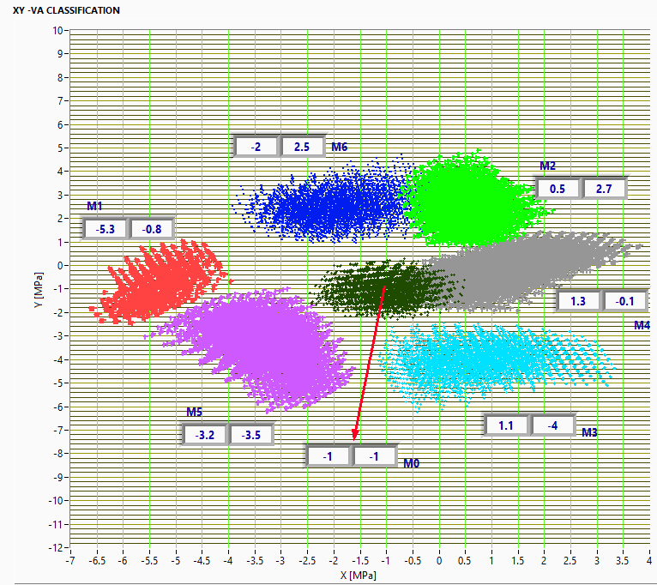
(a)
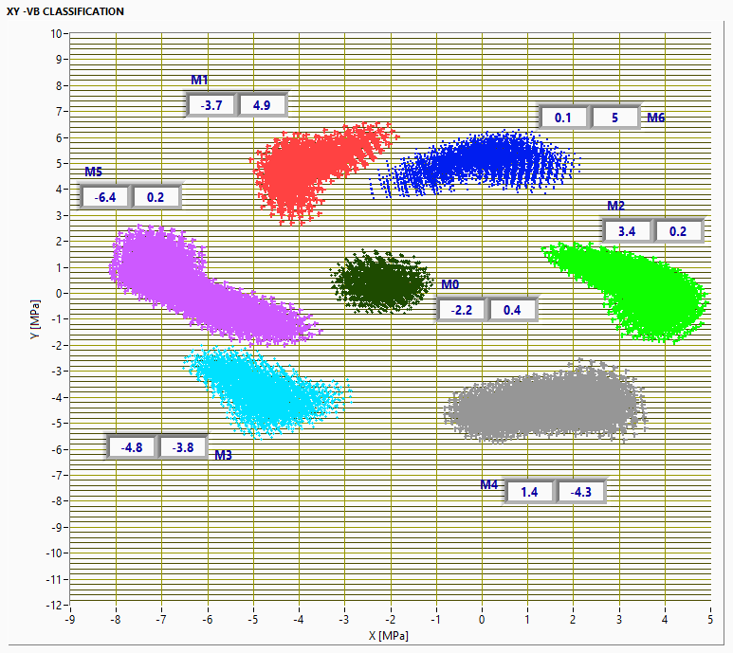
(b)
Fig. 2 Illustrating the seven classes of the MDE 6S46MCC on MV 34000 DWT via new two-dimensional space (VN_{x}, VN_{y}) in accordance with VDS VA (a) and VB (b)
Fig. 3.a shows that when using the maxima VA of the TVS, the pairs of state classes: (D₀ and D₄), (D₂ and D₄), and (D₆ and D₂) couldn't be separated fully in new two-dimensional VN_{A} (VN_{Ax}, VN_{Ay}). However, Fig. 3.b shows that using the minima VB of the TVS, the pairs of state classes are very well separated in the new two-dimensional VN_{B} (VN_{Bx}, VN_{By})
- Conclusion
Using the new method for building two-dimensional VDS has the advantages in classifying R technical states of MDE. The authors applied the new approach for diagnosing the technical sates in the two -axes Descartes (VN_{x} and VN_{y}) using the maxima and minima VDS of the shaft-line TVS. The results show that the minima VDS produces the better classification performance than the maxima VDS.
- References
- Do Duc Luu: Dynamics and diagnostics of marine diesel engine by vibration technique. Publisher “Transport”, Ha Noi (2009).
- Do Duc Luu, et all (2020): Regressive models for condition diagnosing marine diesel engine by torsional vibrations on propulsion shaft-line. International Journal of Modern Physis B. ISSN 02179849. (5 pages). © World Scientific Publishing Company. DOI: https://doi.org/10.1142/S0217979220401268
- Do Duc Luu and Cao Duc Hanh (2021). Automatic Calculation of Torsional
Vibrations on Marine Propulsion Plant Using Marine Two-Stroke Diesel Engine: Algorithms and Software. Journal of The Institution of Engineers (India): Series C. ISSN 2250-0545 Volume 102 Number 1. pp. 51-58.
https://doi.org/10.1007/s40032-020-00626-y
- Do Duc Luu, Cao Duc Hanh, et al. (2021): Smart diagnostics for marine diesel engines us ing torsional vibrations signals on the ship propulsion shaft – line. Naval Engineer Journal. ISSN: 0028-1425. March 2021| Nº 133-1. pp. 143-153 https://www.ingentaconnect.com/contentone/asne/nej/2021/00000133/00000001/art00026
- Luong Cong Nho, Do Duc Luu, et al.: Researching, building simulation of main propulsion plant and main switch-board on the marine cargo ship. National Independent Project on Science and Technology with ID. DTDL.CN-14/15 carried out in Vietnam Maritime University, Hai Phong (2015 -2019).
- Hudong heavy machinery Co. Ltd: Torsional Vibration Calculation Report DE 6S46MC –C7860 kW @ 129 r/min 34,000 DWT. PhaRung Shipyard. DNV Approved 2007.
- Russian Maritime Register of Shipping, Edit 2014: Rules for Classification and Construction of Sea-going Ships. Saint-Petecbuarg, Russian (2014).

