The Response of Consumer Food Price Index (CFPI) due to the Impact of Pandemic COVID-19 on Indian Agriculture Sector

Digvijay Pandey¹, Dr. Nidhi Verma², Tajamul Islam^{3*}, Wegayehu Enbeyle⁴, Binay Kumar Pandey⁵, PMadhusudana Patra⁶
¹Department of Technical Education, IET, Lucknow, India
²Government P.G College for Women, Rohtak, India
³Department of Botany, University of Kashmir, Srinagar-190006, J&K, India
ORCID: https://orcid.org/0000-0003-4037-574X
⁴Department of Biostatistics, Mizan-Tepi University, Tepi, Ethiopia
⁵Department of IT, GovindBallabh Pant University of Agriculture and Technology, U.K, India
⁶SRM-DBT Facility, SRM Institute of science and technology Chennai

*Corresponding Author: E-mail address: islamtajamul66@gmail.com

Abstract
India is an agricultural country and a core source of income for the world population. Indian economy is greatly depending on agriculture that is decrease day by day due to pandemic COVID-19. India is a major exporter of many crop foods. India, Thailand, and Vietnam are the major exports of rice if these stopped exports it reduces the economy up to 15%. A related circumstance is built up with diverse yields too like wheat, sunflower whose fare has been stationary by Kazakhstan, Serbia individually. In India, the end of April is the main source of income to farmers because they sell their rabi crops (wheat, mustard, maize, lentil, chilies, gram, tomatoes) in the market drastically decreases of CFPI may lead to the distress of Indian agricultural economy. The change over time in the price of options on wheat futures reveals increased price volatility in response to growing uncertainty about the COVID-19 impacts.

Keywords: Coronavirus, COVID-19, 2019-nCoV, Pandemic, Public health emergency, Middle-Eastern-Respiratory Syndrome (MERS), Consumer Food Price Index (CFPI)

Introduction
India is an agriculture country that play utmost vital role in Indian economy. Out of total gross domestic product (GDP) agriculture alone contributes 17 % that play very important role in providing employment. Approximately 60% of population income is depending on agriculture sector. In agricultural production, India is at position, which is lagged by US and china [1]. According to food and agriculture organization India is the main producer of many fruits (papaya, guava, mango and banana), vegetables (lemon,okra and chickpea) fibrous crops (cotton, jute) and many spices (ginger, chilly, pepper). Wheat and rice are the main staple food and India is second producer in it (FAOSTAT). Today we all know impact of virus COVID-19 on health, population and largely on Indian economy. COVID-19 has caused quick and articulated changes in consumer food request [2].
What is COVID-19??????
Coronaviruses (CoVs) is a large group of viruses belongs to the family coronaviradea primarily causes various enzootic infections in birds as well as in mammals but, in the previous few decades, humans shown susceptibility to the potential of corona virus infection as well. The epidemic of two deadly viral diseases recently Middle-East respiratory syndrome (MERS) and severe acute respiratory syndrome (SARS) in the year 2003 confirmed the virulence of CoVs when they penetrate species barrier and contaminate the most valuable creature on earth, the humans [6-7]. There are various elements of envelope protein-like get together, sprouting, envelope arrangement, and pathogenesis. The protein It has been recently been discovered that SARS-CoV-E contains a coupling subject known as the postsynaptic thickness protein-95 (PSD95)/Drosophila plate enormous tumor silencer (Dlg1)/zonula occludens-1 protein (zo-1) (PDZ)- restricting theme (PBM), arranged in the last four amino acids of the C end [1]. The PDZ space is a protein-protein cooperation segment that can fix to the C-end of target proteins, for example, the cell connector proteins unpredictable in have cell forms essential for viral disease [2-5]. Coronaviruses stick to explicit cell receptors with the assistance of spike protein, which thus causes a conformational change in spike and afterward intervenes combination between the viral molecules [6].
After the receptor interface and the combination between the viral molecule and plasma layers, there is a blend of intracellular infection explicit RNA and proteins, may be completely in the cytoplasm. During contamination with coronaviruses likewise, with all other RNA infections, replication of genome and interpretation of mRNAs must happen. Henceforth, Expression of coronaviruses starts with translation of two polyproteins, which undergo co-translational proteolytic processing into the proteins that form the replicase complex. After the receptor interface and the combination between the viral molecule and plasma layers, there is a blend of intracellular infection explicit RNA and proteins, may be completely in the cytoplasm. During contamination with coronaviruses, likewise, with all other RNA infections, replication of genome and interpretation of mRNAs must happen [8].
Source of Origin and Transmission
It is very important to know the source and transmission of every disease, so that there would be proper preventive strategies in order to hold the infection. On account of SARS-CoV, the specialists at first centered around various plausible sources like raccoon mutts and palm civets, and these are supposed to be a key pool of Covid-19 contamination. However, merely the samples which are isolated from the civets at the food market indicated high peaks which are reflect as positive results for viral RNA finding, so therefore civet palm might be secondary hosts [9]. In the year 2001, the examples were confined from the overwhelming people of Hong Kong and from there on atomic valuation portrays a 2.5% recurrence pace of antibodies against SARS-coronavirus. These signs give a profound indication that SARS-coronavirus might be flowing in people some time ago causing the flare-up in 2003[10]. Later on, it was found that Rhinolophus bats have anti-SARS-CoV antibodies proposing the bats as a source of viral replication [11]. Way back 2012 when there was an outbreak of The Middle East respiratory syndrome (MERS) coronavirus initial in Saudi Arabia [9]. MERS-coronavirus too pertains to beta-coronavirus and having camels as a zoonotic source or primary host of contamination [12]. In a latestrevision, MERS-coronavirus was also identified in two creatures (bats) namely Pipistrellus and Perimyotis bats [13], proffering that bats are the vital host and spreading mode of the infection [14,15]. At the outset, there was presumption that snakes may be the potential host, in any case, after genomic sequencing it has been discovered that there is a similarity of coronavirus with SARS-like bat infections, strengthened the explanation that snakes are not the principle supplies but rather no one but bats could be the key repositories [16, 17].

Therapeutic strategies against COVID-19
Initially, the use of interferons nebulization, wide range anti-microbial, and hostile to viral medications seemed to lessen the viral weight in Crown positive patients [18-20], However, only the potent drug called remdesivir has revealed promising impact against the virus [21,22]. Remdesivir only and a combo of Remdesivir and chloroquine or interferon beta expressivelyobstructed the replication of SARSCoV-2 and patients were affirmed as clinically and fully recovered [20-23]. Various other enemy of virals drugs like are Nafamostat, Nitazoxanide, Ribavirin, Penciclovir, Favipiravir, Ritonavir, AAK1, Baricitinib, and Arbidol demonstrated gentle to reasonable outcomes when analyzed against the contamination in patients and in-vitro clinical isolates [20,21]. Different mixtures, for example, blending the antiviral or anti-infection agents with standard and natural Chinese medications were likewise assessed in inconsistency of SARSCoV-2 raise disease in mice and people [22-24]. Newly in Shanghai, specialists removed the blood plasma from clinically improved patients of COVID-19 and immunized it in the contaminated patients which show promotable recuperation [24].
Impact of COVID-19 on agriculture
The COVID-19 pandemic viral diseases spread all over the world very quickly and affect all areas of people. With in very short period of time COVID-19 shut down major economy of the world. The lockdown practice, which is trailed by all countries to control COVID-19, will block a wide scope of economy containing cultivation economy. The word “lock down” means the all human activities are turned off in other words production and supply of all materials are not much easier which results people lose their jobs. World economy is totally dependent on import and export of goods (production and consumption of food). If the situation is not controlled it can lead to food “crisis” means shortage of food that result in to malnutrition and death [25,26]. From the march there was increase in agricultural prices because of restrictions of food import and export. Some countries are major exporter of crop foods like India, Thailand and Vietnam are the major exports of rice if these stopped exports it reduces economy up to 15% [27]. A correlated circumstance is built up with diverse yields too like wheat, sunflower whose fare has been stationary by Kazakhstan, Serbia individually. In India, the end of April is mainly source of income to farmers because they sell their rabi crops (wheat, mustard, maize, lentil, chillies, gram, tomatoes) in market. In this pandemic condition, government should take some preventive measures in areas where farmer gathering (mandi) will take place to save farmer economy as well as to control spread of disease. For the benefit of farmers Indian Council of Agricultural Research (ICAR) already issue an advisory like social distancing in the field where they work and hygiene. The advisory also practices guidelines of harvesting, threshing, post harvesting, storage as well marketing of farmer’s products. To uplift the agriculture economy we must use available resources in right way. India has to develop innovative team and techniques in the field of agriculture that increase more productivity and sustainability. After the lockdown the government should make rule to provide quality seeds from seed banks to farmers for the kharif season crops. The indigenous methods should be adopted in the field that costs minimal for crop growth. The advantage of nanotechnology in the field of agriculture is infinite.
- Use of nanozeolites, nanoclays and hydrogels that increase water holding capacity of soil [28].
- Carbon nanotubes, nano metals, nano oxides materials should be use in field that absorb harmful contaminates [29].
- Nanoparticles of gold, silicon, titanium and zinc oxide can be used that increase uptake and mobilization of nutrients [30].
- Nanosensors can be used in agriculture field to check soil pH, pathogen and pest exposure
- Sensor technology can be used in tinier water area to maximize the water use productivity.
Impact of Covid 19 on food supply
The food flexibly chain is a system that associates the whole agrarian framework with the shopper's table, including procedures, for example, producing, bundling, appropriation, and capacity [31]. COVID-19 can possibly impact the smooth capacity of transportation at about each progression along the food flexibly chain. Ailments identified with COVID‐19 could confine the accessibility of talented work force in the transportation segment up and down the food flexibly chain. This mind boggling flexibly tie incorporates contributions to the field, to the capacity, processors and makers, and to wholesalers and retailers [32,33,34]. At first, the declarations of social segregation caused individuals to go to the gracefully focuses and create a deficiency of certain items, regardless of this, the food flexibly has settled in light of the fact that it is one of the frameworks that must be kept up to guarantee food security. One of FAO's jobs is to advance that food esteem chains are not hindered and keep on working [35,36]. Along these lines, notwithstanding the limitations that administrations have forced on the versatility of work in farming frameworks, in spite of the fact that with certain issues, the gracefully of essential necessities is typically guaranteed. The circumstance is distinctive when it comes to products that are imported or sent out; because of the conclusion of outskirts, worldwide exchange was interfered, albeit subsequent to having characterized security conventions to maintain a strategic distance from the spread of the infection, exchange balanced out. This might be impermanent; it relies upon what nations are doing to stop the spread of the infection. Part of the food supply system, are the social programs that some countries, mainly India, have to millions of below poverty line (BPL) families with limited economic resources. This supply system is being served in different ways:
- Door to door delivery of essential commodities to people (for example, Uttar Pradesh, Delhi and Odisha).
- Many state governments did economic allocation equivalent to the cost of food rations of necessity.
Interferences to food moves are negligible, so the food gracefully stays stable; albeit watching China's involvement with this pandemic, there is a more prominent effect on the domesticated animals segment because of challenges in getting to creature feed and, then again, the lack of work [37,38,39]. In spite of the fact that it relies upon the nation and the measures that everyone has received, comprehensively the costs have stayed stable, along these lines, no spikes in the costs of essential necessities are normal, despite the fact that it is bound to happen for high-esteem items, particularly rice, meat, and perishables. One of the files that measure the variety of the cost all through India is the MoSEI Consumer Food Price Index (CFPI), a proportion of the month to month variety of the national costs of a bin of food items. According to the MoSEI, the CFPI of January 2020 had an average of 153.4points, that is, 1.9 points (1.0%) less than in December. Similarly CFPI of February and March are consistently decreasing in the rate of 3.7 and 1.9 respectively. Whereas, before COVID 19 outbreak the CFPI points was consistently increasing as shown in figure 1.
This was because of a sharp fall in the fare costs of vegetable oils and, to a lesser degree, in the costs of meat and oats, which counterbalance the proceeding with ascend in the costs of dairy items and united items. Post lockdown all the food mobilization have been sealed the farmers related to vegetable and milk production are had huge loss. Drastically decreases of CFPI may lead to the distress of Indian agricultural economy. Due to ongoing pandemics there will be volatility in price and consumption because of growing uncertainty in customers [35,36].

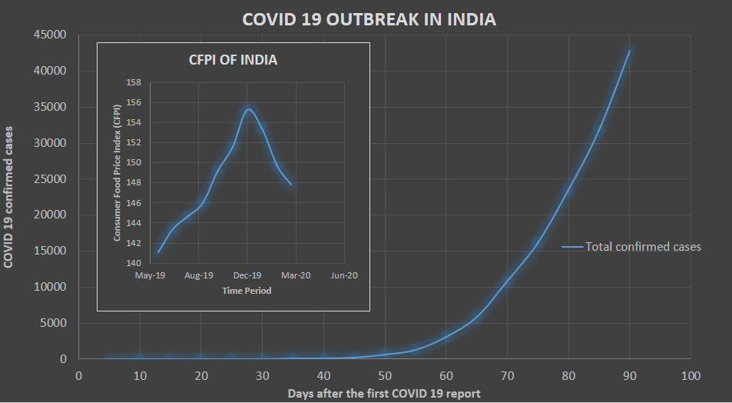
Figure 1. All over India confirmed cases and food price Index by the effect of COVID-19.
*Graph constructed with data from MoHFWfor the COVID 19 cases, and MoSPI for Consumer Food Price Index (CFPI).
Impact of COVID-19 Food demand
Demand suggests the readiness and capacity of purchasers to pay cash for a specific decent or administration, during a specific period [40,41]. The interest for food has diminished because of vulnerability and the decrease of individuals' spending limit, in spite of the fact that this reduction is yet slight; the circumstance could intensify if the pandemic proceeds for quite a while, because of diminished salary and employment misfortunes [42, 43]. Since China represents a significant market in world exchange and where the COVID-19 infection first reported, its experience shows an expansion in online interest in the food and refreshment area, because of isolate approaches. In circumstances like these, where an infection spreads on contact, contactless conveyance administrations become favored by customers. For instance, the individuals who use rambles for item conveyance as shown in figure 2.

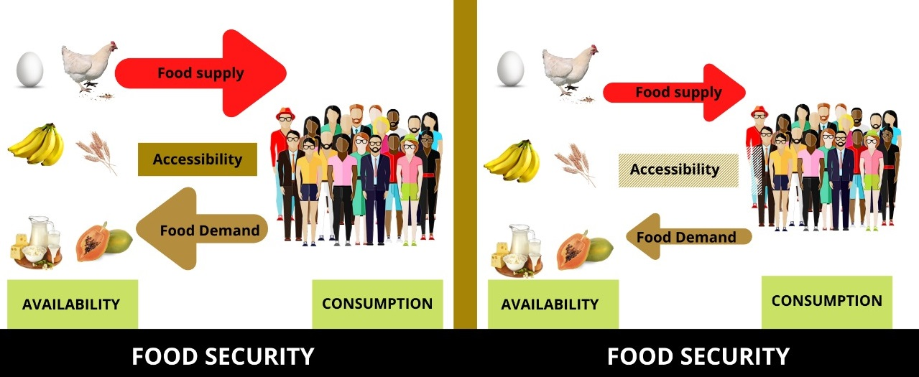
Figure 2. Food security system (a) without COVID-19 (b) with COVID-19.
Both demand and supply have been influenced, although a more noteworthy impact on demand, because of the chance limitations that influence availability. Accessibility and utilization remain practically steady. The agricultural framework incorporates producers, crude materials, agricultural machinery, data sources, preparing plants, ranch, and industrialized food. Consumption incorporates individuals and distinctive market system.
Discussion
In spite of these dealings and in sight of persistent limitations on schedules of individuals and vehicle traffic, distresses are raised regarding negative allegations of COVID19 disease on the Agricultural economy. This is the termination of rabi season in India and yields like gram, wheat, lentil, mustard, etc. (including paddy in irrigated paddy lands) are at the harvestable time or almost getting maturity. Additionally, this is often the stage when the farmer reaches the mandees (market yards) for assured procurement by titled government agencies [36].
On the off chance that we state that we Indians exceptionally reliant on horticulture legitimately or inaccurately it is right. As India is the principle cultivator of numerous food crops so it ought to be fortified by the administration to flood crop yield that can help in the aggregate Indian economy just as to have a tremendous effect. COVID-19 is a major test for India we as a whole have battle together to control this viral ailment. We as a whole ought to follow government rules now and again and mindful of individuals around us.

Conclusion
Finally, the COVID-19 pandemic is a Black Swan event. Government may have the choice to deal with such drastic pandemics (events) in real-time as they arise. No doubt there is no specific prediction about the black swan events like pandemics but a bit of appropriate policy and response should be there to tackle the losses due to these pandemics (events). Drastically decreases of CFPI led to the distress of Indian agricultural economy. Other than short-run emergency policies, such as the Rupees 20 Lakh Crores central government emergency aid and economic stimulus package, governments should tread carefully in making structural policy changes at this time.
Acknowledgement
We are thankful to all the colleagues who gave valuable comments about the manuscript.
Competing interests
We declare that there is no conflict of interest.

References
- Arjun, K. M. (2013). Indian agriculture-status, importance and role in Indian economy. International Journal of Agriculture and Food Science Technology, 4(4), 343-346.
- Rather, R. A., Islam, T., Rehman, I. U., & Pandey, D. (2021). Development of Vaccine against Coronavirus Disease 2019 (Covid-19) In India. Asian Journal of Advances In Medical Science, 13-21.
- Nieto-Torres, J. L., Verdiá-Báguena, C., Jimenez-Guardeño, J. M., Regla-Nava, J. A., Castaño-Rodriguez, C., Fernandez-Delgado, R. et al., (2015). Severe acute respiratory syndrome coronavirus E protein transports calcium ions and activates the NLRP3 inflammasome. Virology, 485, 330-339.
- Islam, T., Magray, J. A., & Zargar, S. A. Role of Herbs against COVID-19. Hospitality and Tourism Industry amid COVID-19 Pandemic, 409.
- Nieto-Torres, J. L., DeDiego, M. L., Álvarez, E., Jiménez-Guardeño, J. M., Regla-Nava, J. A., Llorente, M., et al., (2011). Subcellular location and topology of severe acute respiratory syndrome coronavirus envelope protein. Virology, 415(2), 69-82.
- Teoh, K. T., Siu, Y. L., Chan, W. L., Schlüter, M. A., Liu, C. J., Peiris, J. M. et al., (2010). The SARS coronavirus E protein interacts with PALS1 and alters tight junction formation and epithelial morphogenesis. Molecular biology of the cell, 21(22), 3838-3852.
- Yang, Y., Xiong, Z., Zhang, S., Yan, Y., Nguyen, J., Ng, B. et al., (2005). Bcl-xL inhibits T-cell apoptosis induced by expression of SARS coronavirus E protein in the absence of growth factors. Biochemical Journal, 392(1), 135-143.
- Zargar, S. A., Islam, T., Rehman, I. U., & Pandey, D. (2021). Use of cluster analysis to monitor novel corona virus (Covid-19) infections in India. Asian Journal of Advances in Medical Science, 1-7.
- Bredenbeek, P. J., Pachuk, C. J., Noten, A. F., Charité, J., Luytjes, W., Weiss, S. R., & Spaan, W. J. (1990). The primary structure and expression of the second open reading frame of the polymerase gene of the coronavirus MHV-A59; a highly conserved polymerase is expressed by an efficient ribosomal frameshifting mechanism. Nucleic Acids Research, 18(7), 1825-1832.
- La Monica, N., Yokomori, K., & Lai, M. M. (1992). Coronavirus mRNA synthesis: identification of novel transcription initiation signals which are differentially regulated by different leader sequences. Virology, 188(1), 402-407.
- Kan, B., Wang, M., Jing, H., Xu, H., Jiang, X., Yan, M. et al., (2005). Molecular evolution analysis and geographic investigation of severe acute respiratory syndrome coronavirus-like virus in palm civets at an animal market and on farms. Journal of virology, 79(18), 11892-11900.
- Pandey, D., Islam, T., Magray, J. A., Gulzar, A., & Zargar, S. A. (2021). Use of statistical analysis to monitor novel coronavirus-19 cases in Jammu and Kashmir, India. European Journal of Biological Research, 11(3), 274-282.
- Zheng, B. J., Guan, Y., Wong, K. H., Zhou, J., Wong, K. L., Young, B. W. Y. et al., (2004). SARS-related virus predating SARS outbreak, Hong Kong. Emerging infectious diseases, 10(2), 176.
- Shi, Z., & Hu, Z. (2008). A review of studies on animal reservoirs of the SARS coronavirus. Virus research, 133(1), 74-87.
- Paden, C. R., Yusof, M. F. B. M., Al Hammadi, Z. M., Queen, K., Tao, Y., Eltahir, Y. M., et al., (2018). Zoonotic origin and transmission of Middle East respiratory syndrome coronavirus in the UAE. Zoonoses and public health, 65(3), 322-333.
- Pandey, D., Islam, T., & Malik, M. A. (2021). Novel coronavirus disease (Sars-Cov-2): An overview. Asian Journal of Advances in Medical Science, 8-12.
- Huynh, J., Li, S., Yount, B., Smith, A., Sturges, L., Olsen, J. C., ... & Donaldson, E. F. (2012). Evidence supporting a zoonotic origin of human coronavirus strain NL63. Journal of virology, 86(23), 12816-12825.
- Lau, S. K., Li, K. S., Tsang, A. K., Lam, C. S., Ahmed, S., Chen, H., ... & Yuen, K. Y. (2013). Genetic characterization of Betacoronavirus lineage C viruses in bats reveals marked sequence divergence in the spike protein of pipistrellus bat coronavirus HKU5 in Japanese pipistrelle: implications for the origin of the novel Middle East respiratory syndrome coronavirus. Journal of virology, 87(15), 8638-8650.
- Lu, R., Zhao, X., Li, J., Niu, P., Yang, B., Wu, H., ... & Tan, W. (2020). Genomic characterisation and epidemiology of 2019 novel coronavirus: implications for virus origins and receptor binding. The lancet, 395(10224), 565-574.
- Chan, J. F. W., Yuan, S., Kok, K. H., To, K. K. W., Chu, H., Yang, J. et al., (2020). A familial cluster of pneumonia associated with the 2019 novel coronavirus indicating person-to-person transmission: a study of a family cluster. The lancet, 395(10223), 514-523.
- Ng, C. S., Kasumba, D. M., Fujita, T., & Luo, H. (2020). Spatio-temporal characterization of the antiviral activity of the XRN1-DCP1/2 aggregation against cytoplasmic RNA viruses to prevent cell death. Cell Death & Differentiation, 27(8), 2363-2382.
- Wang, B. X., & Fish, E. N. (2019, June). Global virus outbreaks: Interferons as 1st responders. In Seminars in immunology (Vol. 43, p. 101300). Academic Press.
- Wang, M., Cao, R., Zhang, L., Yang, X., Liu, J., Xu, M. et al., (2020). Remdesivir and chloroquine effectively inhibit the recently emerged novel coronavirus (2019-nCoV) in vitro. Cell research, 30(3), 269-271.
- Rather, R. A., Islam, T., Rehman, I. U., & Pandey, D. (2021). Development of vaccine against coronavirus disease 2019 (Covid-19) in India. Asian Journal of Advances in Medical Science, 13-21.
- Richardson, P., Griffin, I., Tucker, C., Smith, D., Oechsle, O., Phelan, A., & Stebbing, J. (2020). Baricitinib as potential treatment for 2019-nCoV acute respiratory disease. Lancet (London, England), 395(10223), e30.
- Sheahan, T. P., Sims, A. C., Leist, S. R., Schäfer, A., Won, J., Brown, A. J., ... & Baric, R. S. (2020). Comparative therapeutic efficacy of remdesivir and combination lopinavir, ritonavir, and interferon beta against MERS-CoV. Nature communications, 11(1), 1-14.
- Derebail, V. K., & Falk, R. J. (2020). ANCA-associated vasculitis—refining therapy with plasma exchange and glucocorticoids.
- Chen, S., Brahma, S., Mackay, J., Cao, C., & Aliakbarian, B. (2020). The role of smart packaging system in food supply chain. Journal of Food Science, 85(3), 517-525.
- Deaton, B. J., & Deaton, B. J. (2020). Food security and Canada's agricultural system challenged by COVID‐19. Canadian Journal of Agricultural Economics/Revue canadienne d'agroeconomie, 68(2), 143-149.
- Khin, M. M., Nair, A. S., Babu, V. J., Murugan, R., & Ramakrishna, S. (2012). A review on nanomaterials for environmental remediation. Energy & Environmental Science, 5(8), 8075-8109.
- Khot, L. R., Sankaran, S., Maja, J. M., Ehsani, R., & Schuster, E. W. (2012). Applications of nanomaterials in agricultural production and crop protection: a review. Crop protection, 35, 64-70.
- OXFAM Research Reports, Cereal Secrets, pp 9-10. Accessed on November 24, 2020.
- Sekhon, B. S. (2014). Nanotechnology in agri-food production: an overview. Nanotechnol. Sci. Appl. 7, 31–53. doi: 10.2147/NSA.S39406.
- Swaminathan, M. S. (1986). Building national and global nutrition security systems. Natural resources and the environment series.
- Ayenew, B., & Pandey, D. (2020). Challenges and opportunities to tackle COVID-19 spread in Ethiopia. Journal of PeerScientist, 2(2), e1000014.
- India outranks US, China with world's highest net cropland area". Retrieved 17 November 2020.
- ICRISAT report, “Containing COVID 19 impacts on Indian agriculture”. Accessed on April 28, 2020.
- FAO Director-General urges G20 to ensure that food value chains are not disrupted during COVID-19 pandemic. Available in: http://www.fao.org/news/story/en/item/1268254/ico de/
- Zhang, X. (2020). Chinese livestock farms struggle under COVID-19 restrictions. IFPRI book chapters, 84-85. Available from https://www.ifpri.org/blog/chinese-livestock-farmsstruggle-under-covid-19-restrictions.
- Sunny, A. R., Sazzad, S. A., Prodhan, S. H., Ashrafuzzaman, M., Datta, G. C., Sarker, A. K. et al., (2021). Assessing impacts of COVID-19 on aquatic food system and small-scale fisheries in Bangladesh. Marine Policy, 126, 104422.
- Hanashima, M., & Tomobe, K. I. (2012). Urbanization, industrialization, and mortality in modern Japan: A spatio-temporal perspective. Annals of GIS, 18(1), 57-70.
- Du, N., Yang, X. X., Yang, L., Zeng, Y. H., Zou, S. M., Bo, H. et al., (2009). Review on the etiological property of 1957 Asian flu virus (H2N2). Bing du xue bao= Chinese Journal of Virology, 25, 12-16.
- Farmer, P. (2019). Ebola, the Spanish flu, and the memory of disease. Critical Inquiry, 46(1), 56-70.

