IMPACT OF URBANIZATION ON AGRICULTURAL LAND IN MAKURDI LOCAL GOVERNMENT AREA OF BENUE STATE, NIGERIA

Dr. Terwase Shabu, Sussan Fate and Mfanyo Keziah Ukula
Department of Geography,
Benue State University,
Makurdi
tshabu@bsum.edu.ng

ABSTRACT
This study assessed the Impact of Urbanization on Agricultural Land in Makurdi Local Government Area of Benue State. The data collected were population figures and land use for three Epoch (1997, 2007 and 2017). The satellite images were sourced from the National Center for Remote Sensing and Geographic Information System, Jos. In the analysis, cross change detection analysis and overlay analysis using ArcGIS 9.0 was performed to detect where land-use change has occurred and which type of land use agricultural land has transformed too. The GIS analysis revealed that there is an increase in settlement and a decrease in Agricultural land from 1997 – 2017. It also revealed that 99.51ha of agricultural land use has been converted to settlement between 1997 and 2017. The results reveal that urbanization has significant effects on Agricultural Land in the study area and these effects include; decreasing agricultural land, decreasing agricultural activities and decrease in farm size. If the growth in the population of Makurdi LGA continues unchecked, agricultural land will be significantly depleted in the future. The study recommended that there should be effective law and policy to control population growth sustainably to minimize the negative impact of urbanization in the study area. Also, urban agriculture should be encouraged to sustain the food supply in urban areas.

INTRODUCTION
Urbanization is the process of evolution of urban settlements. The increase in the population of the people that live in cities can give rise to urban expansion. This usually is as a result of the net movement of people from rural to urban areas or natural increase (the excess of birth over death). The movement of people from rural to urban areas in search of better livelihood can lead to the expansion of urban areas and an increase in social and economic activities. Urban growth is indicated by an increase in the population of people living in these areas. However, the definition of what qualifies as an urban centre differs from one country to another depending on the criteria used. Urbanization is not a new phenomenon: since around 5000 B.C., it has been happening ^{[1]}. Over the years, the degree of urbanisation, calculated by the proportion of the urban population, has increased ^{[2]}. The urban population, especially in developing countries, has increased more rapidly than the rural population worldwide ^{[3]}.
There are three major concerns over the continuing farmland loss due to urbanization ^{[4]}. First, the diversion of the most fertile agricultural land to urban development decreases agricultural productivity, thus decreasing short-term food supplies and endangering food production in the long term. Second, farmland shortage in rural areas reduces services and the quality of life. Third, the loss of farmland will have a negative impact on the usage of farmland. On the urban periphery, land-use disputes are likely to be more serious as urban growth rises. The role of agriculture and urbanization, however, has always been at the centre of the debate on sustainable patterns of land use in a modern economy.
Urbanization is one of the anthropogenic activities that impact on land use/land cover. The urban environment in which human beings live is a sign of human society and is an important location for the economic and social activities of human beings. Urbanization is a big feature of the modern lives of humans. For a city, to estimate the level of economic, social, science and technological growth, the level of urbanization can be used. In the meantime, monitoring the level of management and organisation of the city is very relevant. As a consequence of these changes in the effect of the urban environment on the natural landscape, the morphology of the river, the drainage system and the land use/land cover of the area, the frequency of water hazards has increased ^{[5]}. While for thousands of years, human beings have been modifying land to acquire food, shelter and other life essentials, the current rates, scale and severity of such modifications are much greater than ever in history. This has caused unprecedented changes at local and regional levels in the biodiversity and environmental processes.
The impact is that there is high demand on the natural resources available and the struggle for them. Land is the most significant natural resource on which all operations are based. Unlike geology, land use is seasonally dynamic and is actually more evolving. Demand for limited land resources for agriculture, forestry, pasture, urban and industrial land use is growing with the rise in population and human activity.
Cities and towns in Nigeria are commonly noted to be rising quite rapidly. The national average rate of urban growth is about 10% per year ^{[6, 7]}. Nigerian cities are growing faster at the height of their growth than their European counterparts ^{[8]}. Increasing demand for land or housing and other urban uses means rapid urban growth. The growth in population and the subsequent urbanization in the country is responsible for increased demand for land that has resulted in land use changes. Among other factors, land-use shifts have arisen at the detriment of agricultural activities.
Over 70% of the population in Benue is engaged in agriculture as a major source of income for the population. Therefore, depriving the people engaged in agricultural activities of land brings with it an increase in the rate of unemployment. For rural and peri-urban farmers, the combined effects of succession and dominance factors have made land increasingly scarce in rural and peri-urban areas. Rapid urbanization has adversely affected development efforts in many cities. One of these is changes in land use subsequently leading to decreased agricultural land in favour of the provision of residential accommodation in most urban settlements. This is reflected in the form of dormitory and satellite towns that are being developed in the urban peripheries which were agricultural lands. The main challenge of the urbanization process is the rapid conversion to urban land use (mostly residential construction) of a significant amount of prime agricultural land in the urban periphery. The result is that prime agricultural land is inaccessible. Low agricultural productivity, low living standards and food insecurity are a result of this.
Urbanization in Makurdi has resulted in significant arable land loss, habitat destruction, as well as social and environmental changes to the urban population. The current urbanization process in Makurdi is an example of a process that not only requires significant attention as a foundation for societal transformation but also for sustainable development ^{[9]}. As cities grow and expand, economic growth and development are expected to advance and act as a catalyst for social development and reform not only of urban areas but of the wider rural hinterland served by the urbanized region ^{[10, 11]}. However, as in Makurdi, this has not been the case. Instead, the city has experienced increased and sustained urban poverty through its increased urbanization; poor environmental sanitation, food crises / shortages, housing, transport and pollution issues. In addition, areas of recent urban growth and urban-poor settlements are the most vulnerable to these challenges.
Agricultural land use may be referred to as how land and its resources are employed for agricultural purpose/development. Land use is very dynamic and has to be monitored at regular intervals to achieve sustainable environmental and agricultural development. The population is a very important factor or agent of change in land use in an area. For instance, as population increases in an area, there is a proportional increase in the expansion of settlements, commercial and industrial activities, thus stimulating conversion of cropland and forest land to settlement as it is the case in Makurdi LGA of Benue State. The importance of agriculture to the people of Benue State in general and the people of Makurdi LGA of Benue State, in particular, cannot be overemphasized. However, in recent times it does seem like agricultural activities and agricultural land use in the area are on the decrease due to the increase in population and urban growth. Despite the threat pose on food security by urbanization in Benue State in general and Makurdi Metropolis and its environs in particular, it is noteworthy that there seems to be little or no systematic and general knowledge about how different rates and levels of urbanization affect agricultural land use in the area and its environs. More so, the relationship between urbanization and agricultural land use in the area seems to have received a limited empirical assessment, particularly in the context of developing countries. It is against these backdrops that this study seeks to evaluate the impact of urbanization on agricultural land use in Makurdi LGA of Benue State and suggest ways of sustainable agriculture in the area.

MATERIALS AND METHOD
The Study Area
Makurdi Local Government Area lies between lat. 70 00l N and 70 45l N and long 80 00l and 80 32l E in the northeastern part of Benue state (Figure 1). It is situated within a physiographic zone called the Benue trough with a mean elevation of 92 meters above sea level. Makurdi is bounded by Gwer West Local Government Area to the west, Gwer East Local Government Area to the south, Guma to the North East and Doma to the North West. Politically, it falls within the Middle Belt region of Nigeria and has a radius of 16 kilometres from its centre. It is the capital of Benue state and headquarters of Makurdi Local Government Area. It serves as a major link between the Northern and Southern parts of Nigeria. The town has several drainage channels. These channels include river Benue, which bisects the town into South and north banks, and its tributaries including Urudu, Demepe, Kereke and Mu and the smaller ones include Idye and Kpege.
According to 1991 and 2006 censuses, the population of Makurdi were 239, 889 and 297 398. Projected at the growth rate of 0.03%, [Pt= 239,889 (1+0.03)26 = 517,342], Makurdi LGA has a total population of 517,342 persons including male and female in 2017. Makudi has a fast-growing population with a population density of 323 persons per square kilometre, about 8.14% of this entire population represent the population of the state ^{[12]}. The 2006 figure was 297 398 including male and female, the male figure was 157, 295 while that of females was 140,103 respectively. The population is made up of the Tiv speaking population as the majority, followed by the Idoma and Igede speaking population with other ethnic groups that are relatively few.

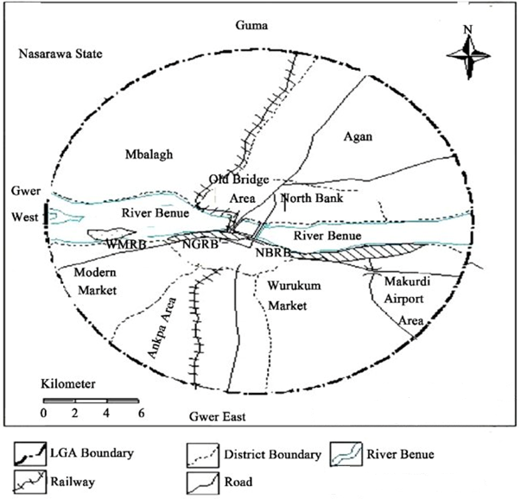
Figure 1: Map of Makurdi Local Government Area
Source: Ministry of Lands and Survey, Makurdi

Although the settlement pattern is a well-planned settlement with street layouts and plots, however, the settlement keeps expanding due to urban growth, while agricultural land keeps shrinking proportionally. The settlement pattern in Makurdi is described as a nucleated type within the urban districts such as high-level, Wadata, Wurukum, Low–level, Kanshio, North bank, Madikpo, new government reserved area (new GRA), Federal housing and Logo ^{[12]} while places at the periphery can be seen as dispersed such as Agan, Fiidi, Mbalagh and Bar ward.
The dominant Land use in Makurdi and its environs are settlement, agriculture, industrial, commercial and infrastructure development among others. Small and large scale industries abound, tourism and recreational areas, telecommunication and transportation. Many secondary schools and primary schools are also found in the area. In terms of higher education, there are two major universities, namely; the Benue State University (BSU) and the Federal University of Agriculture (FUAM).

Method
Assessing the impact of Urbanization on Agricultural Land in Makurdi LGA of Benue State require information on the land use and land cover type for at least two decades, in addition to this, views and observations of the inhabitants are also required. Therefore, the required data for this study include: land use and landcover attribute from the satellite image of the study area for three Epoch (1997, 2007 and 2017) were generated. These images were sourced from the National Center for Remote Sensing and Geographic Information System in Jos, Plateau State. Size of agricultural land, population growth, economic growth, the standard of living, environmental pressure, and industrialization were collected. Also, other variables such as agricultural intensification, population figure for 1997 - 2017 from the National Population Commission (NPC).
The population for this study comprises of the entire inhabitant of the study area. The population of the study area was projected 517,342 people in 2017 using an annual growth rate of 0.03%. Areas of interest will be; Nyiman and its environs, New GRA and its environs, Welfare quarters and its environs, Naka Road (industrial layout) and its environs, and owner’s occupier (international market areas) and its environs among others. These areas are of interest because observation has shown that rapid expansion of settlements and industrial activities in recent time in these areas may not be unconnected with urban growth.
The Landsat imageries were processed using “image classification”, change detection” and “change analysis”. In the GIS analysis, cross-analysis change detection result and overlay analysis was performed using ArcGIS 9.0 to detect “where another land-use change has occurred and which type of land use has agricultural land use transformed into.

RESULTS AND DISCUSSION
Rate of urbanization in Makurdi LGA of Benue State
Population trend in the study area between 1997 and 2007, and 2017 and a forecast from 2017 to 2027 were also analyzed. The trend in population growth in the study area between 1997 and 2007, 2007 and 2017 and what it will be between 2017 and 2027 is presented in Table 1.

Table 1: Population Trend between 1997 and 2027 in Makurdi
Population |  |  |  | Changes between  1997 and 2007 |  | Changes between  2007 and 2017 |  | Forecast Changes between  2017 and 2027
1997 | 2007 | 2017 | 2027 (forecast)
286,440 | 384,951 | 517,342 | 695,264 | Pop change | (%) | Pop change | (%) | Pop change | (%)
 |  |  |  | 98,511 | 34.39 | 138,391 | 45.21 | 177,922 | 62.11
Source: National Population Commission (NPC, 2006)

Table 1 shows that Makurdi had a total population of 286,440 in 1997, a total of 384,951 people in 2007 and 517,342 people in 2017 and it is estimated to reach 695,264 in 2027 (see Figure. 2). The table also reveals the percentage of change (increase) in the population of the study area between 1997 and 2007, 2007 and 2017 and a forecast from 2017 to 2027. It is observed that there is an increase of 34.39% in a population of Makurdi between 1997 and 2007 and there is an increase of 45.21% in population between 2007 and 2017. Similarly, the forecast between 2017 and 2027 shows an increase of 62.11%. It can be inferred that there is a steady increase in population in the study area between 1997 and 2007, 2007 and 2017 and the increase will rise higher between 2017 and 2027. This implies that the population of Makurdi increased by 80% within 20 years. All things being equal, will increase by 142% in 30 years.
For example, these results support the opinion of some early ^{[13, 14]}. Olima ^{[15]} was of the opinion that the rate of population growth in both urban and rural areas is not proportional to the amount of land supply. With increasing population growth, the land is fixed in nature and so does not increase. Urban expansion affects the surrounding areas (i.e. the suburbs) by altering the natural resource base and converting the cover of agricultural land to new uses, thus challenging the environment and livelihoods of the inhabitants. The unprecedented urbanization rate and the sprawling development trend have resulted in the rapid disappearance and/or complete alteration in peri-urban areas of fertile agricultural lands. Between 1990 and 2020, it was projected that approximately 14 million hectares of land (approx. 475,000 ha/yr.) will be transformed into different land use/development in developing countries ^{[16]}. Approximately 400,000 hectares of vegetative land cover has been lost ^{[17]}, with more projected to be lost in most urban settlements due to various physical development projects ^{[18, 19, 20]}. This loss may be attributed to dormitory and satellite cities ^{[21]}, which contribute to the external expansion of built-up areas into green areas primarily used for agriculture outside visible and invisible city boundaries ^{[22, 23, 24]}.

Land use/Land cover Change in Study Area
The changes in land cover/land use between 1997 and 2007 are presented in Table 2. The data shows the total area covered by each feature in hectares and their respective proportions in 1997 and 2007. The Table also reveals the percentage change of land cover types that occurs in the area between 1997 and 2007. A negative change indicates loss of land cover/land use type.

Table 2: Changes in Land cover/land use pattern between 1997 and 2007 in Makurdi
Features | Total Area(Ha) |  | Total Area (%) |  | Change  (%)
 | 1997 | 2007 | 1997 | 2007
Forest | 36.43 | 13.98 | 4.41 | 1.69 | - 2.72
Agricultural Land | 163.88 | 233.23 | 19.86 | 28.27 | 8.41
Grassland | 541.11 | 460.82 | 65.58 | 55.85 | - 9.73
Bareland | 2.28 | 4.50 | 0.2 | 0.54 | 0.34
Settlement | 48.86 | 79.19 | 5.92 | 9.59 | 3.67
Water body | 33.52 | 33.28 | 4.06 | 4.03 | - 0.03
Source: GIS Analysis, 2019
The data revealed that forest, grassland and water body have negative changes of -2.72%, -9.73% and -0.03% between 1997 and 2007, while agricultural land, bare land and settlement have positive changes of 8.41%, 0.34% and 3.67%. It can be deduced that there is an increase in settlement expansion and this may be due to the increasing population in the study area.

Table 3: Changes in Land cover/land use pattern between 2007 and 2017 in Makurdi
Features | Total Area(Ha) |  | Total Area (%) |  | Change  (%) | Period (Years)
 | 2007 | 2017 | 2007 | 2017
Forest | 13.98 | 21.48 | 1.69 | 2.60 | 0.91 | 10
Agricultural Land | 233.23 | 176.72 | 28.27 | 21.42 | - 6.85 | 10
Grassland | 460.82 | 478.59 | 55.85 | 58.01 | 2.16 | 10
Bareland | 4.50 | 1.66 | 0.54 | 2.01 | 1.47 | 10
Settlement | 79.19 | 114.01 | 9.59 | 13.81 | 4.22 | 10
Water body | 33.28 | 33.51 | 4.03 | 4.06 | 0.03 | 10
Source: GIS Analysis, 2019

Figure 2: Areal Extent of Land Use/Land Cover in Makudi
Source: GIS Analysis, 2019

Figure 3: Change in Land Use/Land Cover (%)
Source: GIS Analysis, 2019

The change in land use/land cover between 2007 and 2017 is presented in Table 3, Figure 2 and Figure 3. The data show the total area covered by each feature in hectares and their respective proportions (in percentage) in 2007 and 2017. The Table also reveals the percentage of change in land cover types that occurred in the area between the given periods. A negative change indicates loss of land cover/land use type. The table revealed that agricultural land has a negative change of -6.85%, between 2007 and 2017, while Settlement has a positive change of 4.22%, forest, grassland, bare land and water body have a positive change of 0.91%, 2.16%, 1,47% and 0.03%.
It can be inferred that there is a steady increase in settlement expansion in Makurdi between 2007 and 2017 which may not be unconnected with the increase in population, it can also be deduced that there is decrease or loss in agricultural land use in the study area, while there is an increase in settlement within the same period and this may not be unconnected with the settlement expansion within the period (see satellite images for these changes in Figure 4-6)

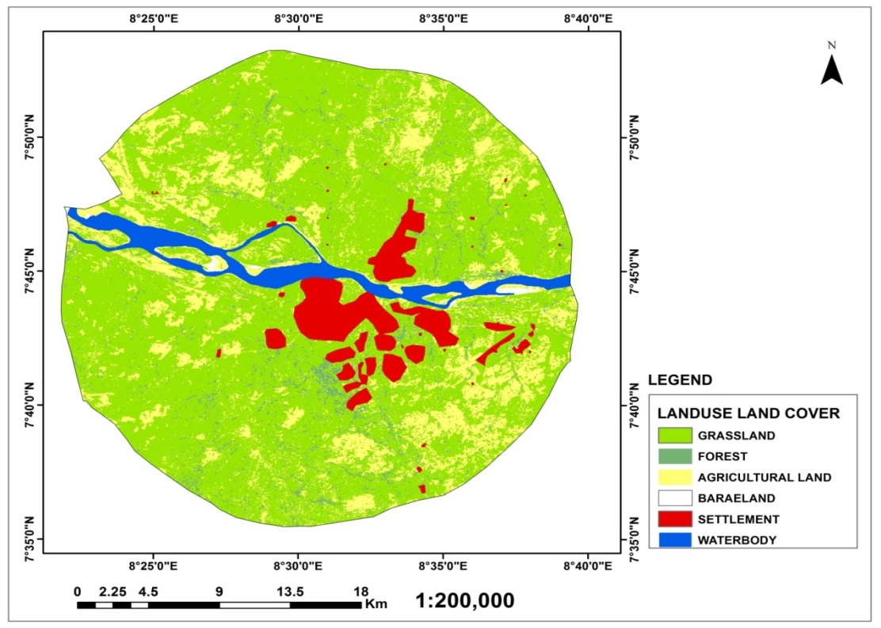
Figure 4: Land use Land cover of the Study Area in 1997.
(Source: Author GIS Analysis, 2019)
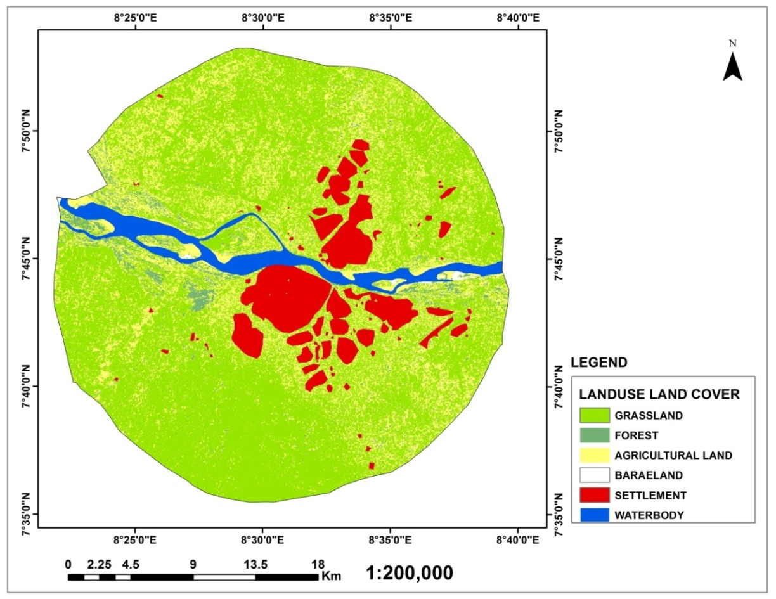
Figure 5: Land use Land cover of the Study Area in 2007
(Source: Author GIS Analysis, 2019)

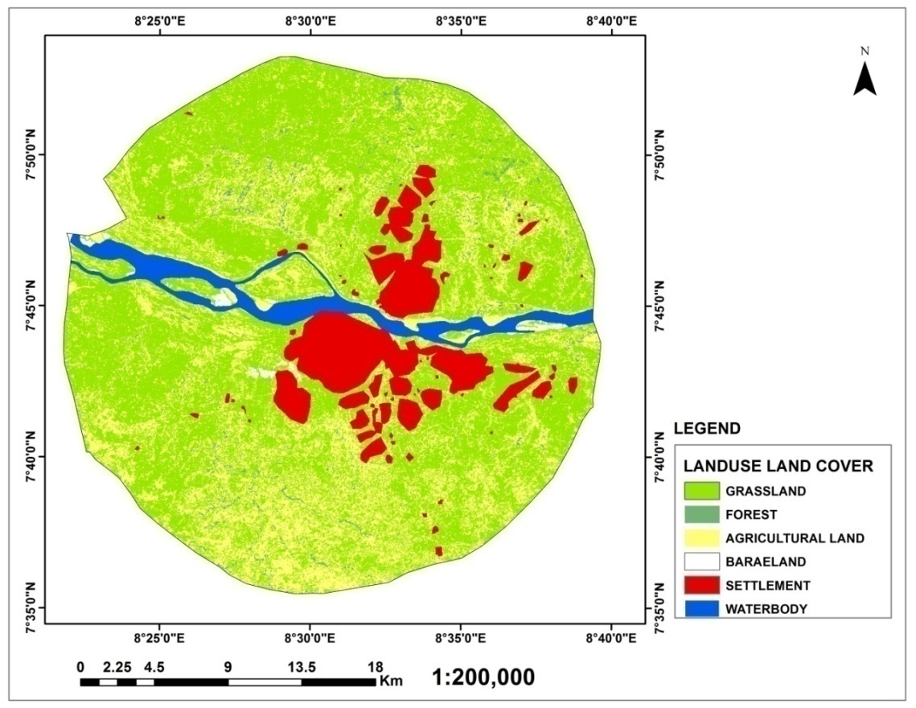
Figure 6: Land use Land cover of the Study Area in 2017
(Source: Author GIS Analysis, 2019)
Effects of Urbanization on Agricultural land use n Makurdi LGA
This section focuses on the loss of agricultural land use between 1997 and 2017 concerning urbanization in the study area. Emphases are on how human influence through settlement and other land use affect agricultural land in Makurdi LGA, Benue State.
Table 5: Loss in Agricultural Land Use from 1997-2017
land use change 1997- 2017 | Area in hectare
Agricultural land to Grassland | 47.40
Agricultural land to Forest | 52.90
Agricultural land to Bareland | 44.16
Agricultural land to Settlement | 99.51
Agricultural land to Waterbody | 24.7
(Source: Author GIS Analysis 2019)

Table 5 shows a loss in agricultural land in Makurdi L.G.A between 1997 and 2017, but the focus of the study is how much of agricultural land has been converted to settlement between 1997 and 2017. The Table revealed that 99.51Ha of agricultural land use have been converted to settlement between 1997 and 2017. The data also show how much other land covers such as grassland, forest and bare land, affect agricultural land use within this period. The conversion of agricultural land to settlement suggests that urbanization has an effect on agricultural land use in the study area. It can therefore be inferred that one of the major effects of urbanization on agricultural land use in Makurdi, Benue State is the conversion of farmland to the built-up area.

Figure 7: Loss in Agricultural Land from 1997-2017 (Area in hectare)

The foregone results further show that urbanization has caused a substantial reduction in the arable lands in Makurdi LGA and the surrounding communities. This finding supports the assertion of Appiah, Asante and Nketiah, (2019) that agriculture land conversions have occurred in most peri-urban zones across the globe which has reduced croplands over the past two decades. The pressure put on agricultural land by the urbanization process puts peri-urban and rural food production increasingly at risk (Eaton & Hilhorst, 2003 and FAO, 2000) as well as threat to food security and reduction in the livelihood of those that depend on these farmlands. The socio-economic impact is the loss of livelihood by farmers and people that participate.
Conclusion
The importance of agriculture to economic development to Nigeria in general and Benue State, in particular, cannot be overemphasized. This study has established that urbanization has significant effects on agricultural land in the area and these effects include decreasing agricultural land, decreasing agricultural activities and a decrease in farm size. Adequate policies must be put in place to curtail the effects of urbanization on agricultural land in the area. The population of Makurdi has grown more than double in twenty years and it is projected to further double that increase in thirty years. Therefore, agriculture competes for land with other urban land uses, which generate higher economic rents. If this growth in population continues unchecked, agricultural land will decrease significantly in the future in the study area. The study, therefore, recommends the following: there should be laws and policies to control population growth in a sustainable manner in urban areas, agricultural intensification should be encouraged so as to boost agricultural productivity in the area and urban agriculture should be encouraged within urbanized areas for sustainable food supply in urban areas.

References
[1]. Sjoberg, A. (1960) The Pre-industrial City: Past present and future Free Press, New York
[2]. Fellmann, J., Getis, A. and Getis, J. (1996). Human Geography: Landscape of Human Activities, USA, Times Mirror Higher Education Group, Inc.
[3]. Lambin, E. F., Geist, H. J. and Lepers, E. (2003). Dynamics of Land-use and Land-cover changing Tropical Regions, Annual Review Environmental Resources, 28.
[4]. Oueslati, W., Sulenie, J. and Wu, J. (2014). Urbanization and Agricultural Structural Adjustments: Some Lessons From European Cities, Working Paper.
[5]. Mandere, M. N., Ness, B. and Anderberg, S. (2010). Peri-urban development, livelihood change and household income: A case study of Peri-urban Nyahururu, Kenya. Journal of Agricultural Extension and Rural Development, 2(5), 73-83.
[6]. Oguntoyinbo, J.S. (1981) Aspect of Urban Microclimate. The Case of Ibadan. In: Sada, P.O. and Oguntoyinbo, J.S., Eds., Urbanization Processes and Problem in Nigeria, Ibadan University Press, Ibadan, 137-139.
[7]. Adedeji, Adebayo (1973) Urbanization Challenge in Nigeria: A Race Against Time. In Adedeji, A and Rowland, L (eds) Management Problems of Rapid Urbanization in Nigeria. Ile-ife: University of Ife Press.
[8]. NITP. (2014). The State of Urban and Regional Planning in Nigeria. NITP,
[9]. Muhammed, S. N., Sabiu, N. and Khalil, M. S. (2015) An overview of urbanization and its challenges on sustainable development in Nigeria. Dutse Journal of Pure and Applied Sciences 1(1), 19 – 29.
[10]. Shabu T., (2010). The Relationship between Urbanization and Economic Development, International Journal of Economic Development and Investment, Vol. 1, No. 2 & 3.
[11]. Sati, V. P., Deng, W., Zhang, S., Wan, J. and Song, X. (2017). Urbanization and Its Impact on Rural Livelihood: A Study of Xichang City Administration, Sichuan Province, China, Chinese Journal of Urban and Environmental Studies, Vol. 5, No. 4.
[12]. Denga, D. I. (1995). Tiv People: origins, Migrations and Social Set-Up, Benue State, The Land of Great Potentials: A Compendium, edited by Denga, D. I, Rapid Educational Publishers ltd, Nigeria.
[13]. Angel, S., Sheppard, S., and Civco, D. (2005). The Dynamics of Global Urban Expansion. Washington, DC: World Bank.
[14]. Adeboyejo, T. and Abolade, O. (2007), Household Responses to Urban Encroachment on the Rural Hinterland in the Ogbomoso Urban Fringe, Nigeria. http://www.populationenvironmentresearch.org/workshops.jsp#w2007
[15]. Olima, W. H. A., (2003). Urbanisation and Housing Challenges. Cities in Africa Conference. Rapporteur’s report
[16]. Naab, F. Z., Dinye, R. D. and Kasanga, R. K. (2013). Urbanisation and its Impact on Agricultural Lands in Growing Cities in Developing Countries: A Case Study of Tamale in Ghana. Modern Social Science Journal, 2, No. 2, 256-287.
[17]. Adesina F.A, (2005). Geo-information and Natural Resources Exploitation in Africa; United Nations Economic and Social Council. Paper Delivered in Fourth Meeting of the Committee on Development Information, Addis Ababa on 23-28 April.
[18]. Appiah, D. O. Bugri, J. T. Forkuo, E. K. and Boateng, P. K. (2014). Determinants of Peri- Urbanization and Land Use Change Patterns in Peri-Urban Ghana. Journal of Sustainable Development; Vol. 7, No. 6; 2014 ISSN 1913-9063 E-ISSN 1913-9071 Published by Canadian Center of Science and Education
[19]. Dekolo, S. O and Olayinka, D. N. (2014). Monitoring peri-urban land use change with multi temporal Landsat imagery. Retrieved from https://www.researchgate.net/publication/265476498 accessed on 13 August, 2017.
[20]. Mugish, J. and Nyandwi, E. (2015). Kigali City Peri-Urbanization and its Implications on Peri-Urban Land Use Dynamics: Cases of Muyumbu and Nyakaliro. GeoTechRwanda 2015 – Kigali, 18- 20 November 2015
[21]. Zasada, I. (2011). Multi-functional peri-urban agriculture-A review of societal demands and the provision of goods and services by farming. Land Use Policy 28, 639–648.
[22]. Brennan, E M (1999) Population, Urbanization, Environment and Security: A Summary of the Issues, Washington DC, Woodrow Wilson International Center for Scholars Comparative Urban Studies Occasional Papers Series, 22.
[23]. Kwasi N. G. (2004). Urbanization Process – Environmental and Health Effects in Africa. Population Environment Research Network (PERN) Cyber seminar, Urban Expansion: The Environmental and Health Dimension.
[24]. Oyesiku, K and Alade, W. (2010). Historical Development of Urban and Regional Planning in Nigeria State of Planning Report, Nigerian Institute of Town Planners

