**Legends for Figures**

Figure 1. a) Box plot showing bacterial population (CFU g-1× 105 dry soil) in the organic and chemical field plots during 30 Days After Sowing (DAS). The bacterial population was normalized with control in each group.

Figure 1 b) Box plot showing bacterial population (CFU g-1× 105 dry soil) in the organic and chemical field plots during 90 DAS. Significant difference (*p* < 0.05) in bacterial population (asymbiotic nitrogen fixing bacteria, ANFix; nitrifying bacteria, Nit and protein hydrolysing bacteria, PHydro) was observed between organic and chemical field plots. The bacterial population was normalized with control in each group.

Figure 2. The appearance of phenological events of maize plant (VE: Emergence, V3: Third leaf collar, V6: Sixth leaf collar, V10: Tenth leaf collar, VT or Tasseling: last branch of tassel is completely visible; and reproductive phases; R1: Silking, R2: Blister, R3: Kernels are yellow with white milky fluid, R4: Dough, R5: Dent, and R6: Physiological maturity) in the organic, chemical and control field plots.

Figure 3. The PCA biplot of the chemical field plots showing the association of rhizosphere bacterial groups and physico-chemical factors.

Figure 4. The PCA biplot of the organic field plots showing the association of rhizosphere bacterial groups and physico-chemical factors.

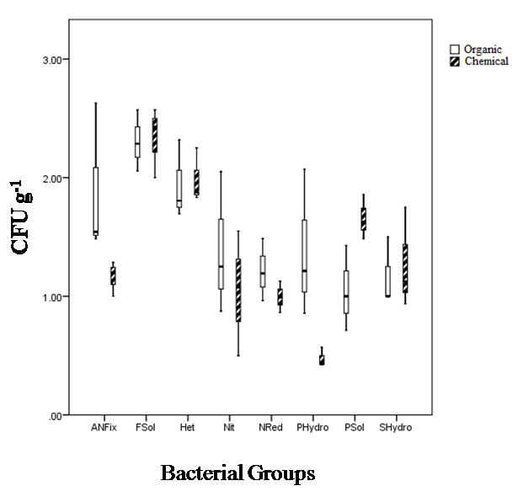

Figure 1a.

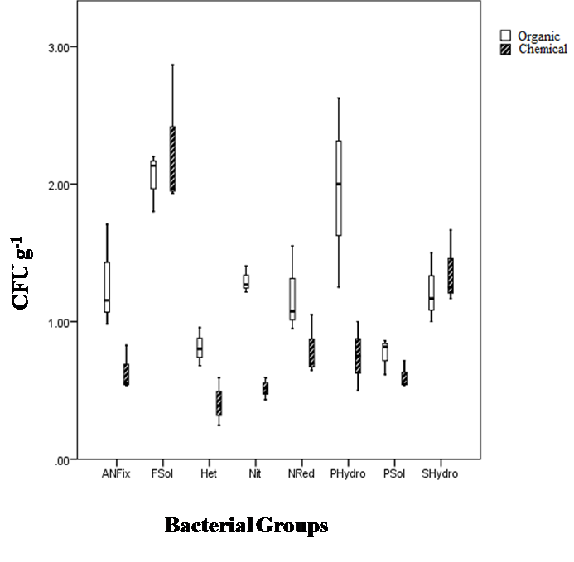

Figure 1b.



Figure 2.



Figure 3.



Figure 4.