Type of the article (Research Article, Review Article, Short Communication, etc.)

Title
(Accurately, clearly and generally state the main focus of the study)
Firstname Lastname ¹, Firstname Lastname ² , Firstname Lastname ² *
¹ University Department, University Name, City, State ZIP/Zone, Country
² Group, Laboratory, City, State ZIP/Zone, Country
*Corresponding Author: Firstname Lastname, University Department, University Name, City, State ZIP/Zone, Country; Email: e-mail@e-mail.com ORCID id: https://orcid.org/0000-xxxx-xxxx-xxxx
Abstract: The abstract should be kept to a maximum of 300 words. It reports concisely on the main findings of the research. To this end, the abstract is structured in Background, Methods, Results and Conclusions, Significance. Kindly ensure the abstract is self-contained and remains readable to a wider audience. For this reason, references are not allowed.
Keywords: Keyword1; keyword2; keyword3
(List three to eight pertinent keywords specific to the article, and can best highlight the research focus of this article, which is conducive to the retrieval of scholars with this need.)

The suggested section titles given are for articles. Review papers and other article types have a more flexible structure.
Remove this paragraph and start section numbering with 1.

Introduction
This section usually uses the method of literature review to outline the background, current status and the unresolved problems of the field, thus highlighting the reasons and significance of the research, etc.

Materials and Methods
In this section, the methods used to obtain the results in the paper should be clearly elucidated. This allows readers to be able to replicate the study in the future. Authors should ensure that any references made to other research or experiments should be clearly cited.

Results
In this section, the results of experiments conducted should be detailed. The results should not be discussed at length in this section. Alternatively, Results and Discussion can also be combined to a single section.
This section can be divided into subheadings and focuses on the results of the experiments performed.

3.1. Subsection
3.1.1. Subsubsection
3.1.2 Subsubsection

3.2. Subsection
3.2.1. Subsection

........................

Figures
Figures include photographs, scanned images, graphs, charts and schematic diagrams. These captions should be numbered (e.g., Figure 1, Figure 2, etc.) . All figures and tables must have a brief title (also known as caption) that describes the entire figure without citing specific panels, followed by a legend, defined as description of each panel. Please identify each panel with uppercase letters in parenthesis (e.g., (A), (B), (C), etc.) . All figures should be legible in print form and of optimal resolution.

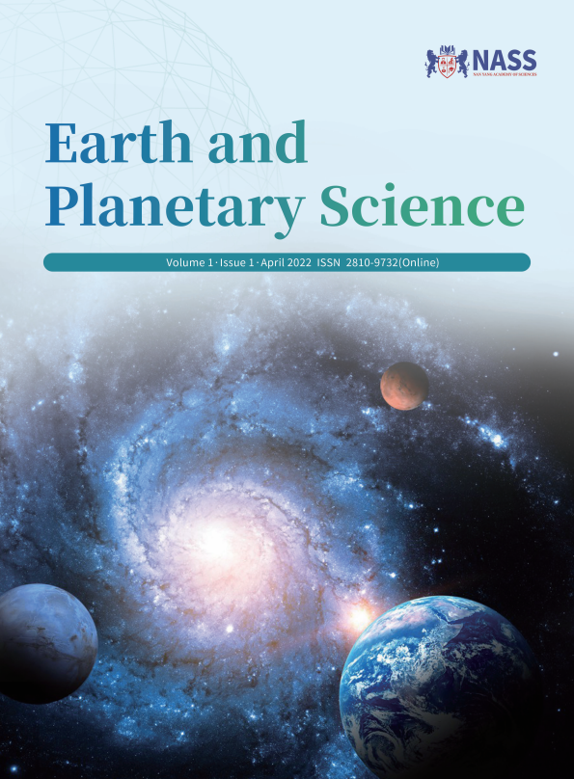

Figure 1. The cover of the journal
Tables, lists and equations
Tables created using Microsoft Word table function are preferred. The tables should include a title at the top. Titles and footnotes/legends should be concise. These must be submitted in the manuscript. Likewise, lists and equations should be properly aligned and its meaning clear to readers.
Equations please use the MathType add-on. Equations should be editable by the editorial office and not appear in a picture format.
For listing items within the main body of the manuscript, please use Roman numbers in parenthesis (e.g., (i), (ii), (iii), (iv), etc.).

Table 1. The title of the table
xxx | xxx | xxx
0.001 | 0.002 | 0.03

Note:
All figures, tables, lists and equations should be mentioned in the text and placed in their corresponding places instead of at the end of the text..

Discussion

In this section, the results of the experiments conducted can be discussed in detail. Authors should discuss the direct and indirect implications of their findings, and also discuss if the results obtain reflect the current state of research in the field. Applications for the research should be discussed in this section. Suggestions for future research can also be discussed in this section. It should not be redundant or similar to the content of the results section. A combined Results and Discussion section is often appropriate.

Conclusions
This section offers closure for the paper. An effective conclusion will need to sum up the principal findings of the papers, highlighting its importance and relevance, and its implications for further research.

Author Contributions

The role(s) that each author undertook should be reflected in this section. This section affirms that each credited author has had a significant contribution to the article.

Funding
Please add: “This research received no external funding” or “This research was funded by NAME OF FUNDER, grant number XXX” and “The APC was funded by XXX”. Check carefully that the details given are accurate and use the standard spelling of funding agency names at https://search.crossref.org/funding. Any errors may affect your future funding.

Acknowledgments
In this section, you can acknowledge any support given which is not covered by the author contribution or funding sections. This may include administrative and technical support, or donations in kind (e.g., materials used for experiments).

Data Availability Statement
Authors should state where data supporting the results reported in a published article can be found, and under what conditions the data can be accessed. They also include links (where applicable) to the data set.

Conflict of Interest

Declaration of conflict of interest. All conflict of interest needs to be disclosed. If authors who have nothing to declare are encouraged to add "All authors disclosed no conflict of interest." in this section.

In-text citations

In-text citations should be numbered consecutively in superscript square brackets.

For example:
Wavelet analysis has long been successfully used in the study of climate series ^{[1]}.

Fabio ^{[2]} studied both technical and scale...

References

All references should be numbered consecutively in the order of their first citation.
Journals:
[1] Singh, S., Nayak, S., 2020. Development of sustainable livelihood security index for different agro-climatic zones of Uttar Pradesh, India. Journal Of Rural Development. 39(1), 110-129. DOI: https://doi.org/10.25175/jrd/2020/v39/i1/125991
[2] Mondal, B., Singh, A., Singh, S.D., et al., 2017. Augmentation of water resources potential and cropping intensification through watershed programs. Water Environment Research. 90(2), 101-109. DOI: https://doi.org/10.2175/106143017X1490296 8254700
Books:
- Zotz, G., 2016. Plants on plants: the biology of vascular epiphytes, 1st ed.; Springer International Publishing: Switzerland. pp. 1–282.
Online publishing:
[4] Lewis, D., Mertens, K., Stock, J., 2020. Weekly Economic Index. Retrieved from FRED, Federal Reserve Bank of St. Louis. https://fred.stlouisfed.org/series/WEI. (Accessed 26 May 2020).

Appendix A
If there is more than one appendix, they should be identified as A, B, etc. The appendix is an optional section that can contain details and data supplemental to the main text.

Appendix B
All appendix sections must be cited in the main text. In the appendices, Figures, Tables, etc. should be labeled starting with “A”—e.g., Figure A1, Figure A2, etc.

